Source Code:

*# Importing the library for flask server communication***from** flask **import** Flask  
  
*# Execution for the main program*app = Flask(__name__)  
  
***# Call the function when endpoint encounter "/total" in address bar***@app.route(**"/total"**)  
**def** list_sum():  
  
 *# List received from background services* numbers_to_add = list(range(10000001))  
  
 *# Initialising the value to zero* total = 0  
  
 *# Iteration for elements in the list* **for** item **in** numbers_to_add:  
  
 *# Adding the elements of the list* total = total + item  
  
 *# Dictionary creation* dict_total = {  
 **"Total "**: total  
 }  
  
 *# Returning the total in the form of Dictionary* **return** dict_total  
  
***# Call the function when endpoint encounter "/number" in address bar***@app.route(**"/<int:num>"**)  
  
*# Pass the number to the function as***def** list_add(num):  
  
 *# number received from background services via address bar* numbers_to_add = list(range(num))  
  
 *# Initialising the value to zero* total = 0  
  
 *# Iteration for elements in the list* **for** item **in** numbers_to_add:  
  
 *# Adding the elements of the list* total = total + item  
  
 *# Dictionary creation* dict_total = {  
 **"Total "**: total  
 }  
 *# Returning the total in the form of Dictionary* **return** dict_total

Create The Flask Server and Activation:

Install Flash

Root_folder/set FLASK_APP=app.py

Root_folder/venv/scripts/activate

Root_folder/set FLASK_ENV=development

Root_folder/flask run

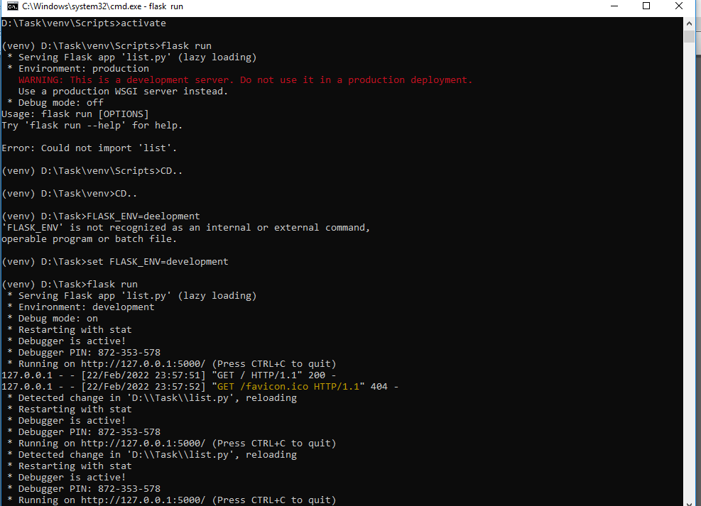

Output on Browser

